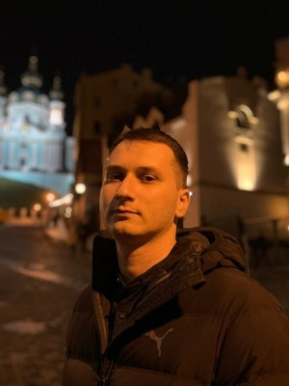
Dykyi Mykhailo

SEO Team Lead / Senior SEO
Full employment
Age: 29 years old
City: Kyiv
Ready to work: Remote, Kyiv

Contact Information
Mobile: +38093-092-22-46
Email: dmgroupmisha93@gmail.com
Social networks: LinkedIn

Experience

SEO Team Lead
from 01.2021 to now
NDA, Kyiv (IT)
Responsibilities:
- Launch and development of iGaming projects in the foreign market (UK, CA, FR, BR, DE, AU, NZ, ES, BE, NL, NO, SE, FI, IT, CL)
- Management of a team of SEO specialists and linkbuilders
- Manage the SEO team, strategy & tactics to get more traffic and revenue
- Research iGaming niche, search trends & opportunities
- Quarterly/yearly budget planning, reporting and performance analysis
- KPI setting and performance monitoring
- SEO Planning and working on product iGaming projects

Senior SEO Specialist
from 05.2019 to 02.2022
Noosphere, Kyiv

- (SEO for satellites: USA, UK, AU, NZ, CA, FR, AT, DE, SE, NO)
- Improvement of position in search results in Google
- Traffic analysis
- Tracking results
- Making reports and recommendations
- External factors consideration while SEO
- Creating SEO strategies

SEO Specialist
from 01.2017 to 05.2019 (2 years 4 months)
Boosta, Kyiv (Advertising and PR services, Promotion of own products)
• Work experience with Tier1-2 GEO. (USA, UK)
• Practical experience in linkbuilding (manual search for donors by metrics, placement of dofollow links of the following types: profile, bookmarks, web 2.0, comments, forums);
• Knowledge of SEO tools: Ahrefs, Majestic, Semrush, Google Analytics, Google Webmaster, Screaming Frog SEO Spider, Netpeak Checker/Spider.
• Performance of typical tasks for optimization of pages in large volumes.
• OnPage/OffPage optimization, compilation of technical specifications for programmers and copywriters;
• Monitoring and analytics of search engine competitors.
• Setup and launch of new projects on Wordpress CMS

Content manager
from 11.2016 to 01.2017 (2 months)
Release Education, Kyiv (Education, science)
• Editing and implementation of new ideas on the corporate site - release.ua.
• Filling the site with content. Work with the company's internal Internet platform, control of teaching and editing of teacher lesson reports.
• Filling and promoting Facebook page, Instagram profile and Youtube.
• Work with contractors SEO-Studio and Binotel.

Editor, administrator of Wordpress sites, assistant director
from 11.2015 to 09.2016 (10 months)
DM-Group, Кyiv (IT)
• Creation of sites on WordPress templates for sale;
• Internal optimization of pages (meta tags, alts, text and linking);
• Increasing the mass of links (purchasing links on stock exchanges, thematic catalogs, forums);
• Creation and adjustment of AdWords and Direct contextual advertising;
• Control of tasks by programmers and copywriters;

Engineer
from 03.2014 to 02.2015 (11 months)
Iron-Logic (Security systems, security)
- Diagnostics of access control and management systems (ACMS)
- Replacement and shipment of equipment by Nova Poshta

Education

KNUTD
Mechatronics and Computer Technologies, Kyiv
Higher education, from 2012 to 2017 (4 years 4 months)

Professional and other skills
- Computer skills
- Google Sheets, Libreoffice, Excel, Redmine
Google Analytics, Search Console, Data Studio
- WordPress
- SEO

Language knowledge
- Ukrainian ─ fluently
- Russian ─ fluently
- English ─ average

Additional Information
Work experience in such niches as writing service, gambling and betting.
Skype - misha_18121993
Viber\Telegram - 0930922246

